Supplementary Materials

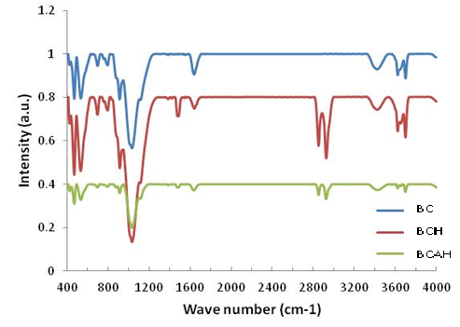
(a)
(b)
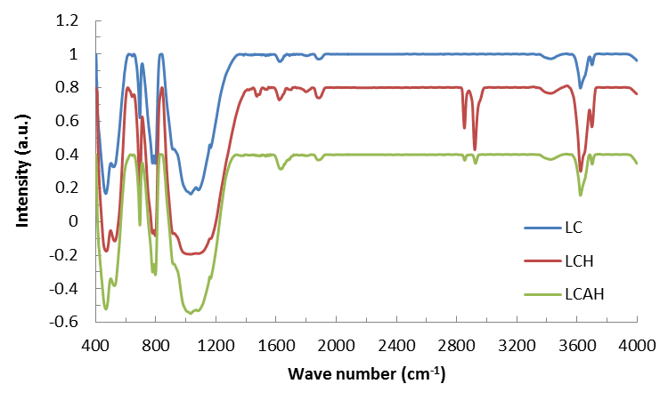

Figure S1. FT-IR spectra of (a) bentonite and modified bentonite and (b) local and modified local clay samples [21].
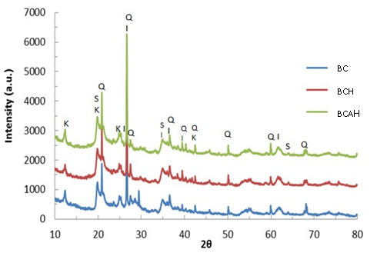
(a)

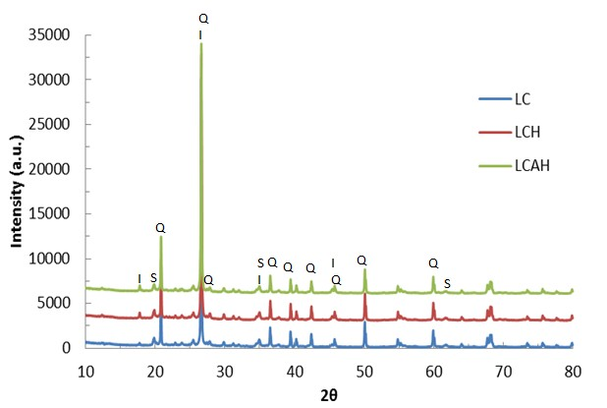
(b)
Figure S2. X-ray diffraction pattern of (a) bentonite and modified bentonite and (b) local clay and modified local clay samples. [S: Smectite; K: Kaolinite; Q: Quartz] [21].

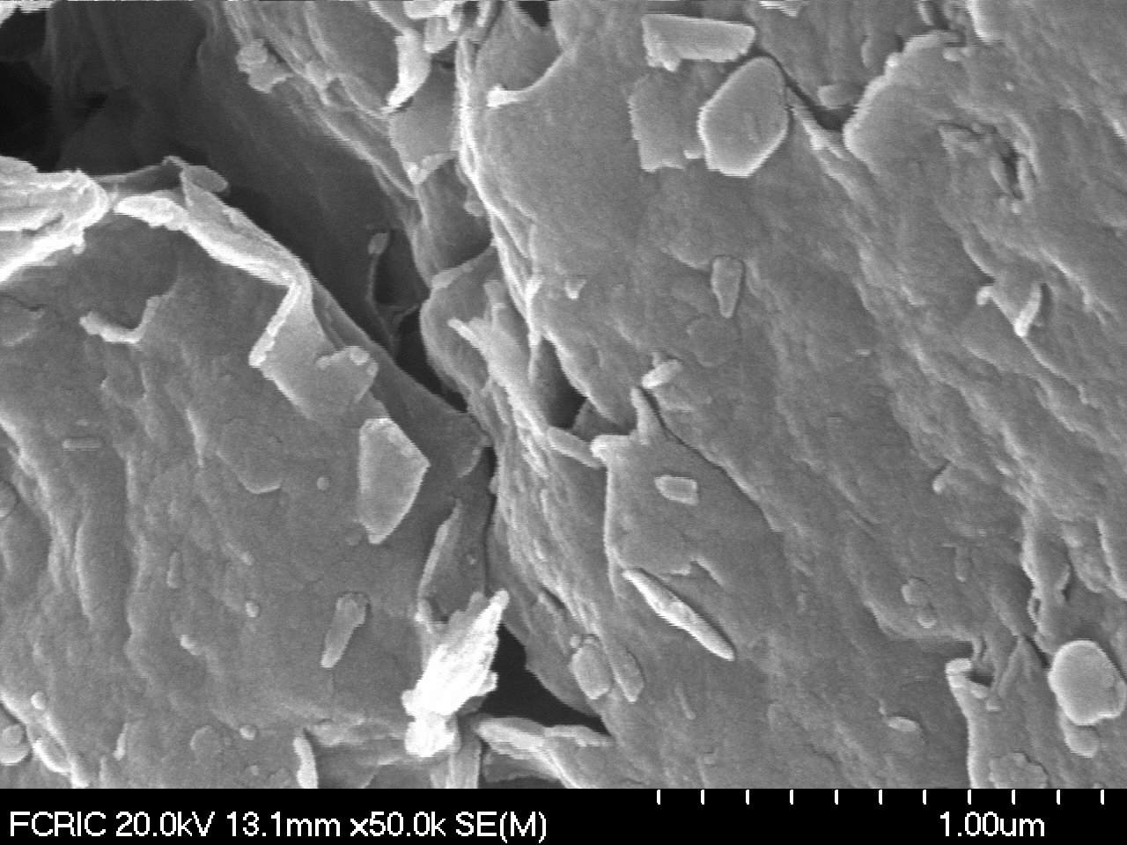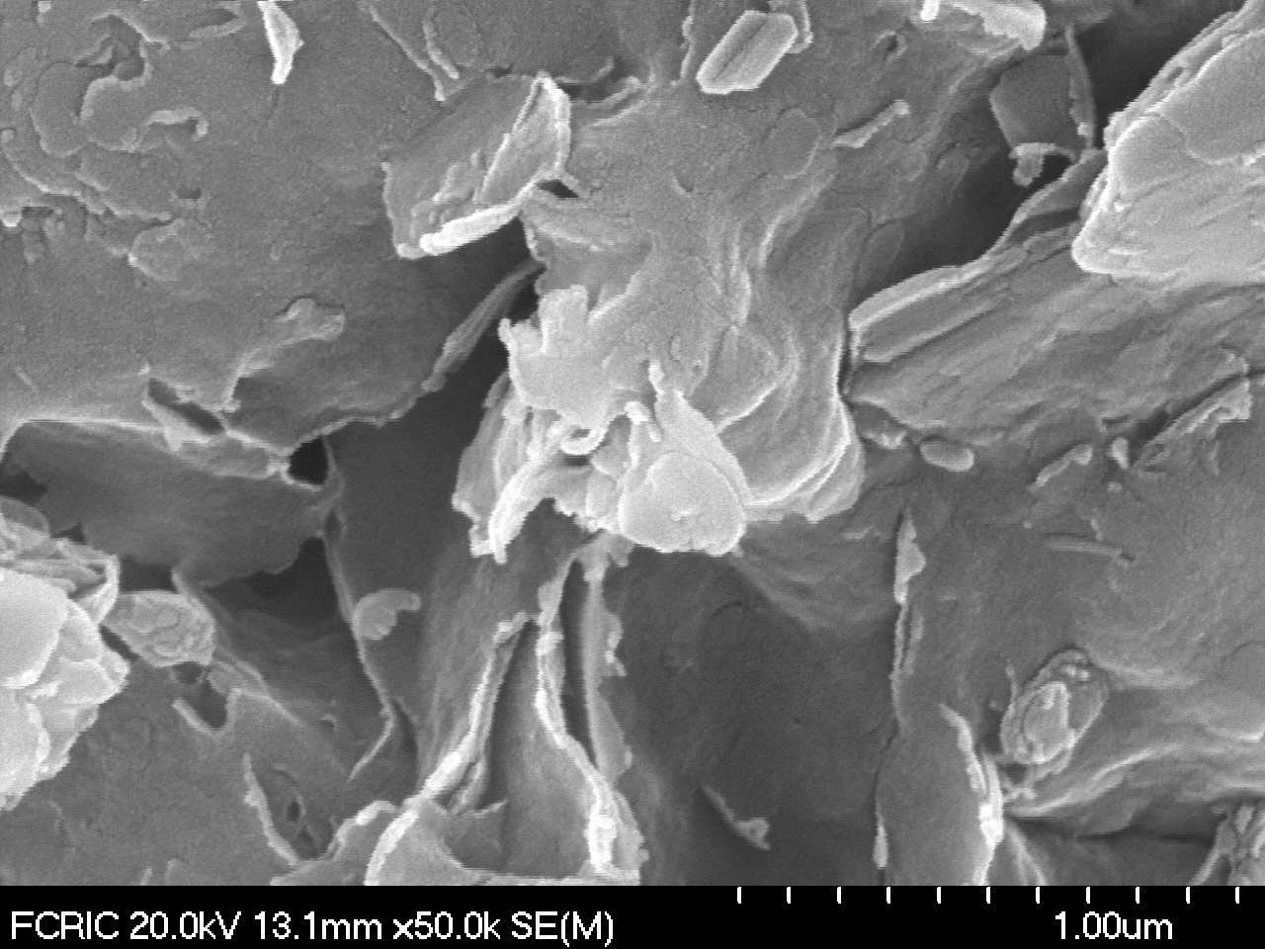
(b)
(a)

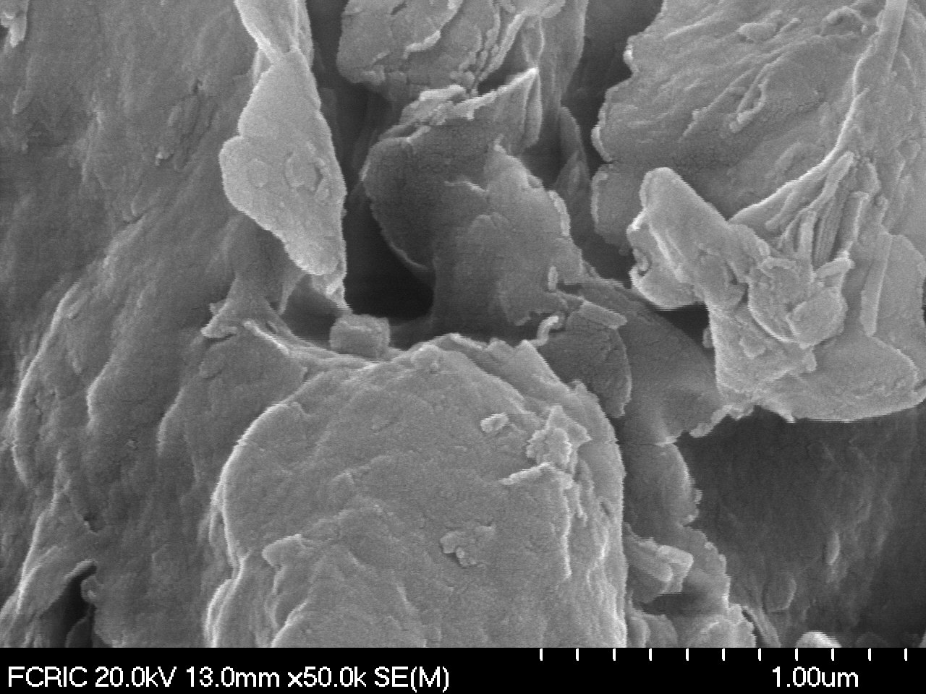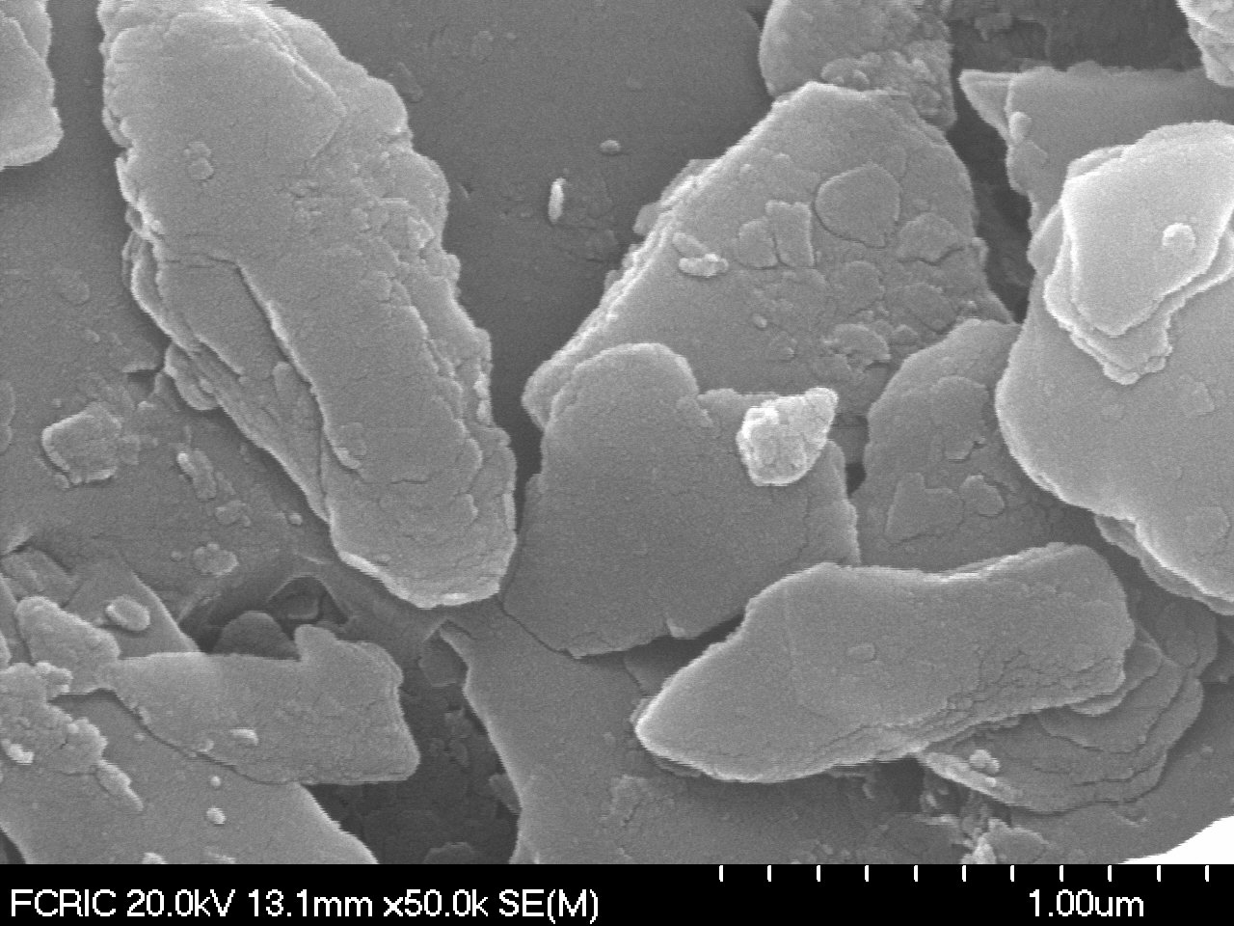
(d)
(c)

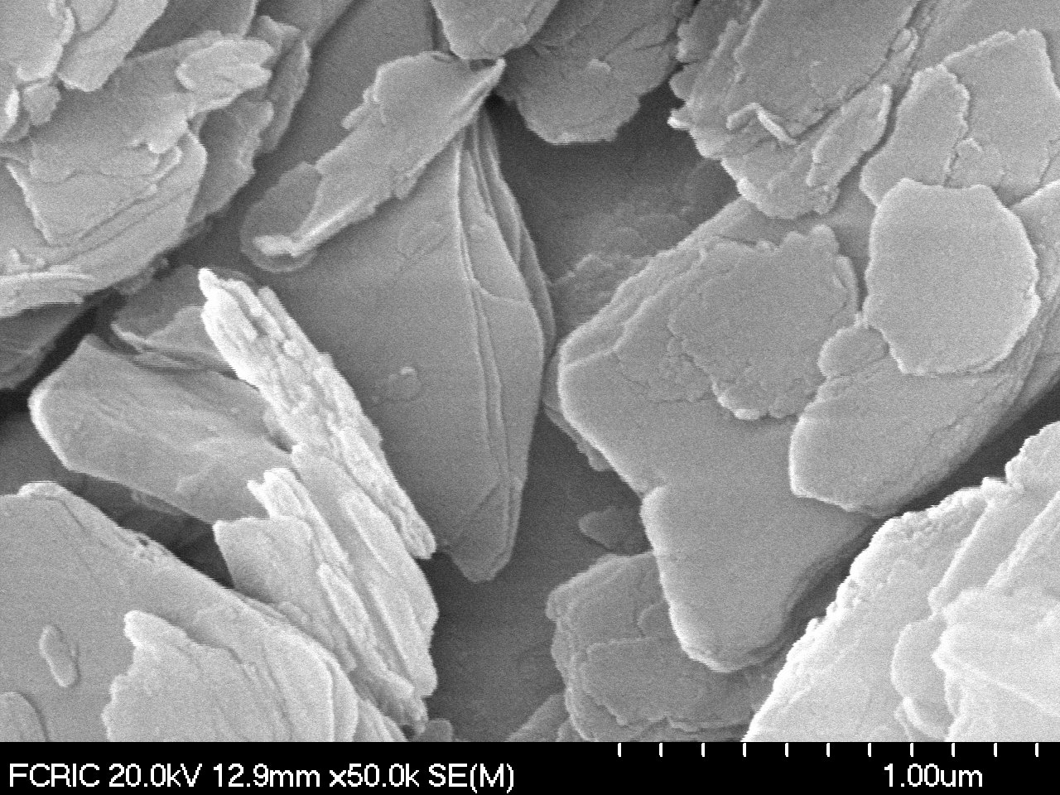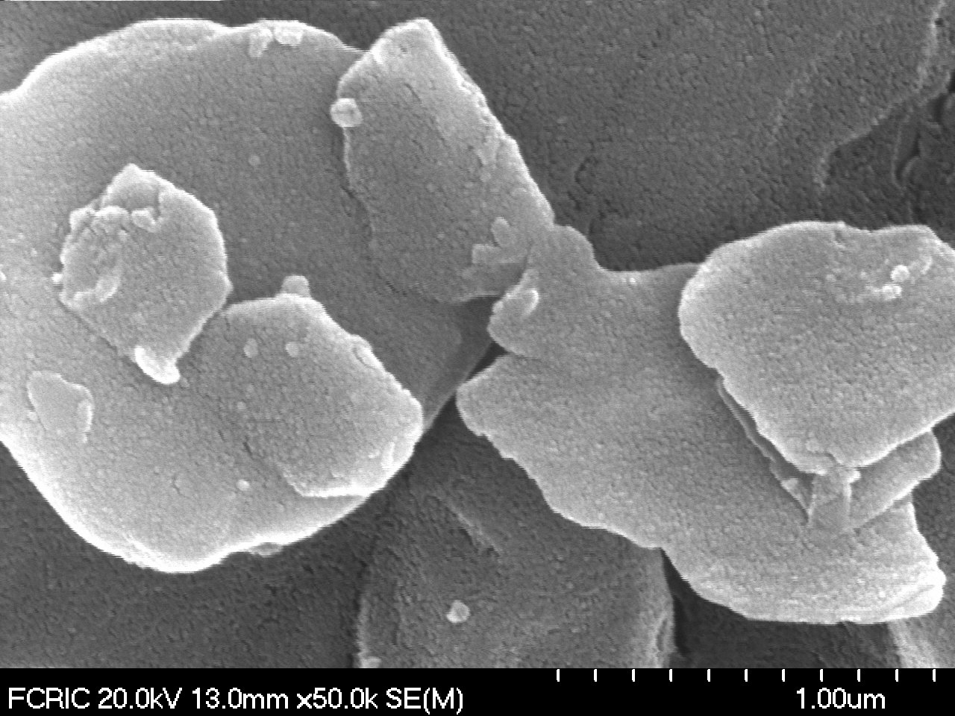
(f)
(e)

Figure S3. SEM images of (a) BC; (b) BCH; (c) BCAH; (d) LC; (e) LCH; and (f) LCAH solids [21].

