

Tutorial for Reviewers

Version 10.2 – 1/2014

Copyright © 2014, Aries Systems Corporation

This document is the confidential and proprietary information of Aries Systems Corporation, and may not be disseminated or copied without the express written permission of Aries Systems Corporation. The information contained in this document is tentative, and is provided solely for planning purposes of the recipient. The features described for this software release are likely to change before the release design and content are finalized. Aries Systems Corporation assumes no liability or responsibility for decisions made by third parties based upon the contents of this document, and shall in no way be bound to performance therefore. Editorial Manager is a registered trademark and the property of Aries Systems Corporation.
Reviewer Tutorial 3
Reviewer Software Requirements 3
Registering with Editorial Manager 3
Duplicate Registration Check 4
Selecting Classifications 6
Entering Keywords 7
Choosing a User Name 8
Custom Registration Questions 9
Multiple E-Mail Address Request 9
Proxy Registration 10
Logging In 10
Time Zone Display 11
Multi-Language Toggle 11
Changing a Password 12
Entering Unavailable Dates 12
Receiving Reviewer Invitations 13
Accepting a Reviewer Invitation 14
Declining a Reviewer Invitation 14
Receiving Reviewer Assignments 15
Deep Links 15
Similarity Check Results 16
Submitting a Review 17
Reviewer Recommendation Page 18
Selecting a Recommendation 18
The Review Form 19
Attachments 21
Submitting the Review 22
Re-Opened Reviews 23
Communicating with the Editorial Office 23
Receiving Attachments 25
Author Response to Reviewers 25

Reviewer Tutorial

Reviewer Software Requirements

Reviewers using Editorial Manager must have Adobe Acrobat Reader (a PDF reader) installed on their systems. If needed, Acrobat Reader can be downloaded at the following address:

http://get.adobe.com/reader

Difficulties with installing or using this Acrobat Reader should be reported to the publication’s IT department for assistance. Adobe also offers a help database for the free Reader at this address:

http://www.adobe.com/support/reader

For general Software and Hardware requirements when using EM, please use the following link:

http://www.editorialmanager.com/homepage/homefaq10.html

A pop-up alert box is displayed if a user accesses the system with an unsupported browser.

Registering with Editorial Manager

The ‘Register’ option is found in the navigation bar for a publication’s Editorial Manager site. New users simply click on ‘REGISTER’.



The following screen will be displayed:

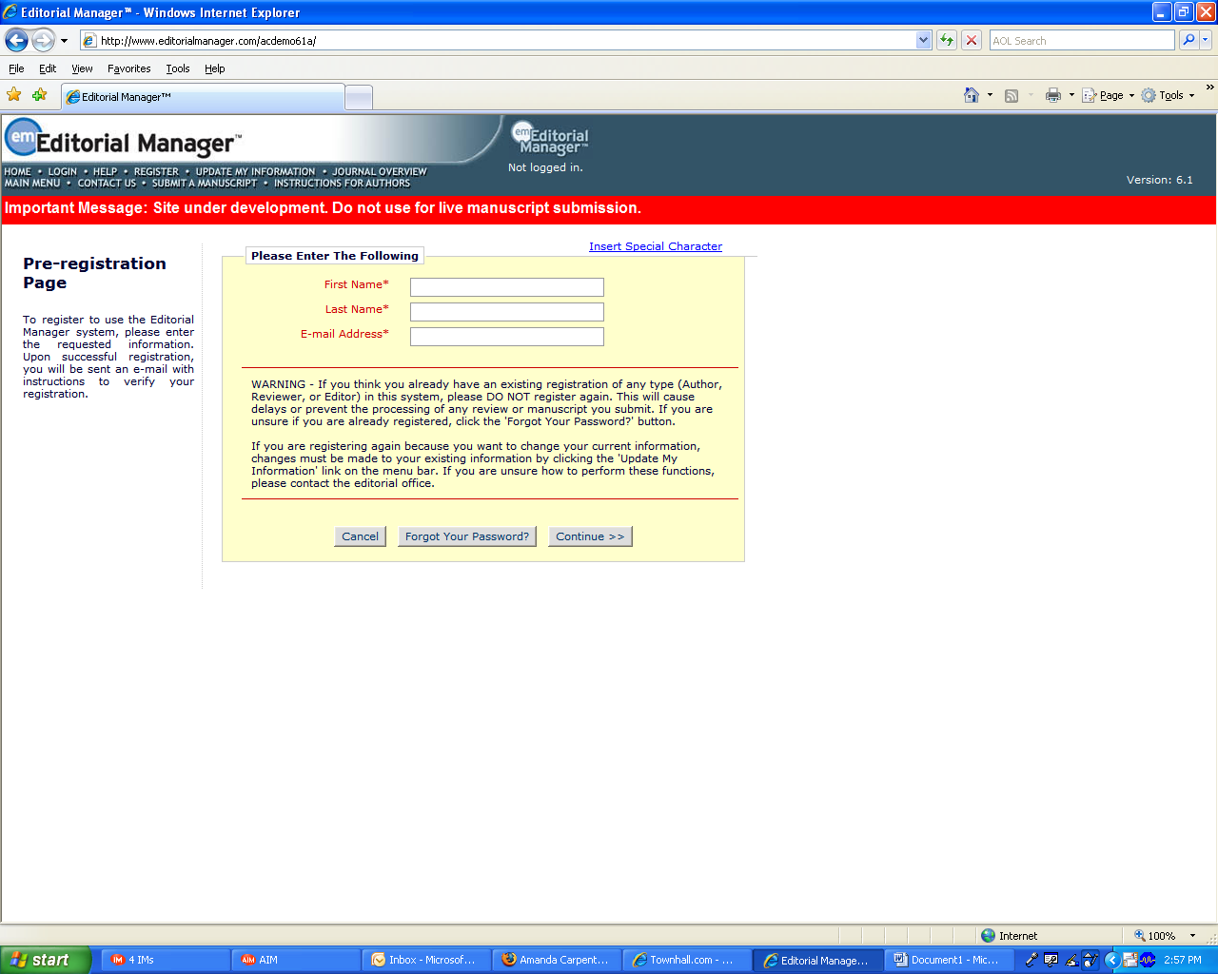

A new user must fill in the Required Pre-Registration information and click ‘Continue >>’ when finished. There will then be a ‘Duplicate Registration Check’.

Duplicate Registration Check

EM will check whether the new user has already registered on the site once First Name, Last Name and E-Mail Address have been entered. The user clicks on the button labeled ‘Continue’. This will execute a search of the database for a duplicate record.

Note: It is important that a new user enters his or her name exactly as he or she is known. It is not unusual for variations of spelling to cause duplicate entries into the database

If a match is found (i.e., the presence of duplicates), the user cannot proceed with the Registration process at this time. EM gives the user the option of receiving an e-mail containing the Username and Password to the e-mail address already in the system.

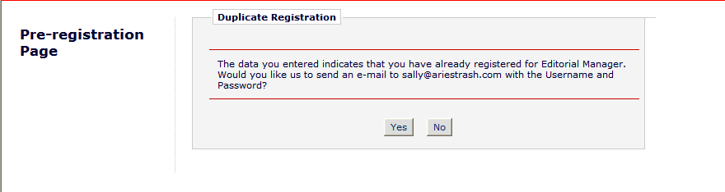

If a user has already be registered clicking ‘Yes’ will send the username and password to the provided e-mail address. Clicking ‘No’ will return the user to the registration page, where the First Name, Last Name or E-Mail address may be changed.

If no matches are found (i.e., no duplicates), then the user will proceed to the second step in the Registration process.
Personal Information
Upon completing Pre-Registration, the user is brought to the ‘Registration’ page:

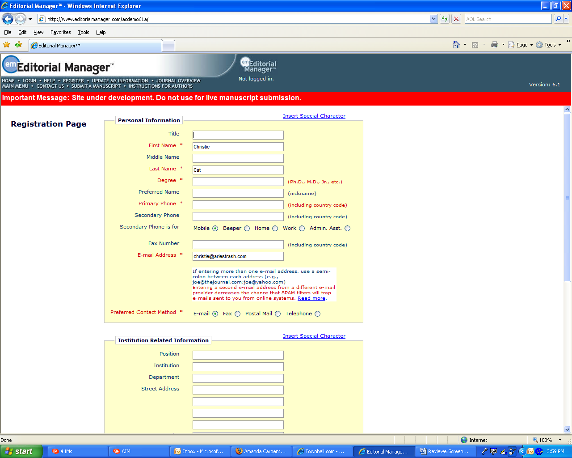
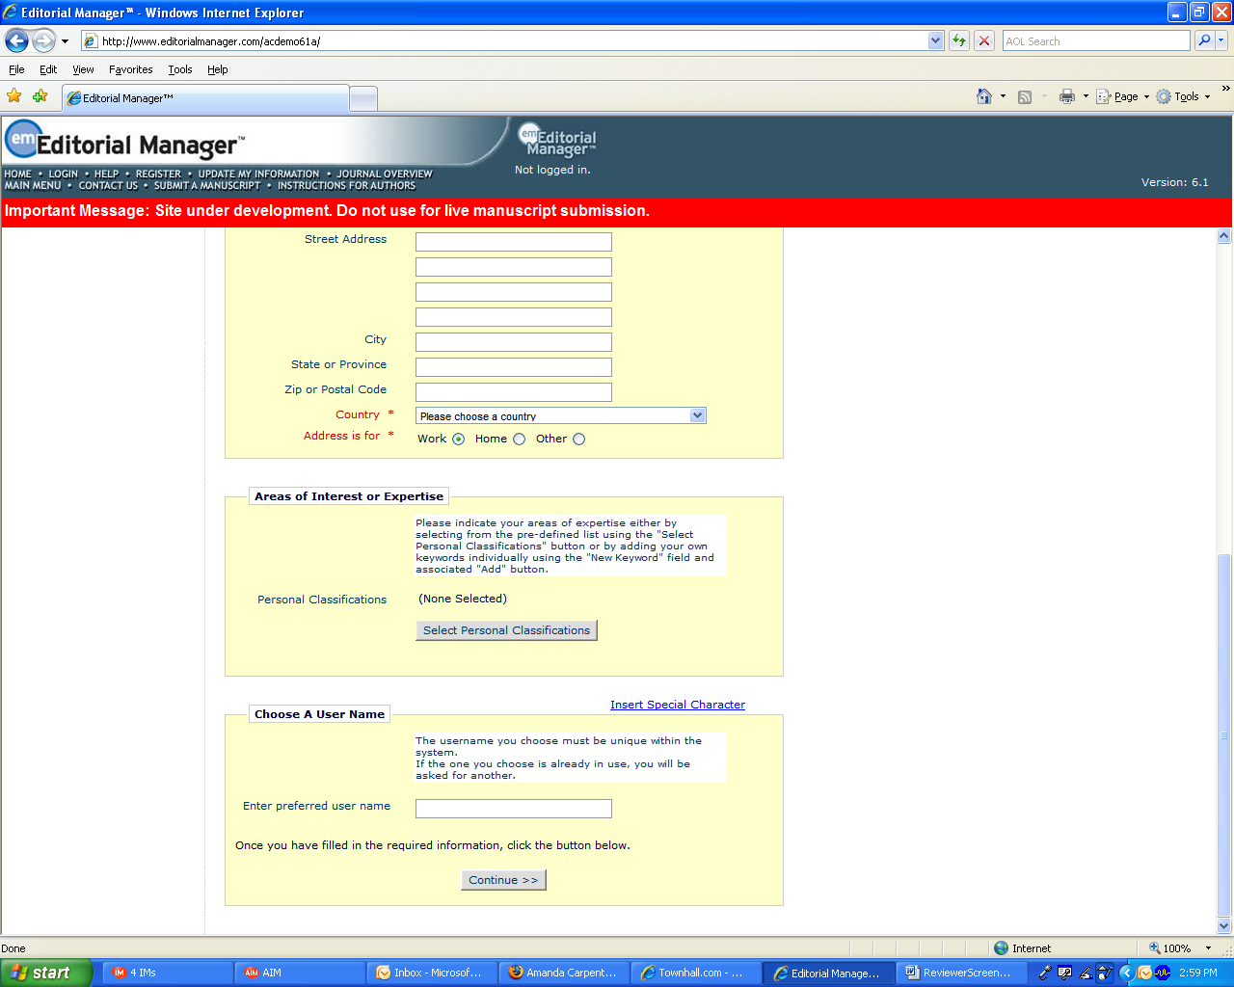

Note: Information fields marked with asterisks (*) are required fields and cannot be left empty.

Some Publications may elect to have a Reviewer Role automatically assigned when new users register for EM. If this feature is enabled, all new user registrants will automatically be assigned to the Reviewer Role designated by the Publication.

If the Publication does not use this feature, and a new user would like the Editorial Office to know that he or she is available as a Reviewer, he or she can set the option ‘Available as a Reviewer?’ to ‘Yes’. This means that when an Editor is searching for Reviewers, this user’s name will appear in a list of possible Reviewers. However, a new registrant simply stating that he or she is available to review does not assign a ‘Reviewer’ role. The Editorial Office must then designate the user as a Reviewer in the EM System.

Selecting Classifications

If the publication is using classifications, the Reviewer may also select personal classifications from the predefined list. This will give the Editorial Office the ability to match personal areas of expertise to manuscripts with the same classifications.

The user clicks on ‘Select Personal Classifications’ to access the screen to enter areas of expertise.
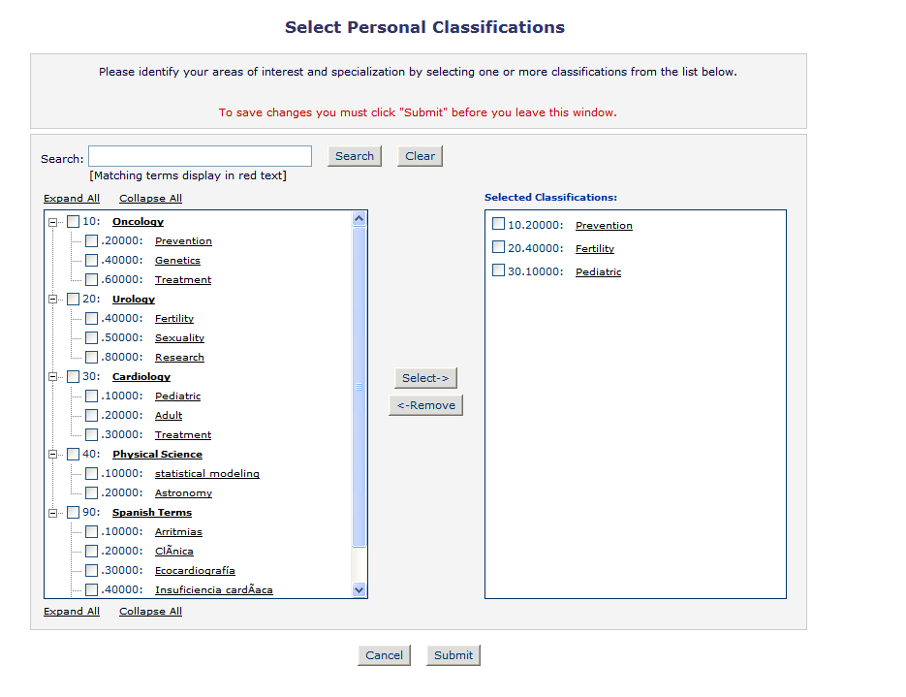

Note: If the Editorial Office has set up classifications as a required field, users must select areas of expertise from this predefined list.

The predefined list can be expanded or collapsed by clicking the [+] or [-] checkboxes. To select, check the appropriate classification and click on the ‘Select’ button. The number of Personal Classifications allowed is determined by the publication. When the appropriate areas of expertise have been selected, click on the ‘Submit’ button on the bottom of the page.

If the publication has Classification Ranking enabled, users may be asked to specify levels of personal expertise for their selected Personal Classifications.
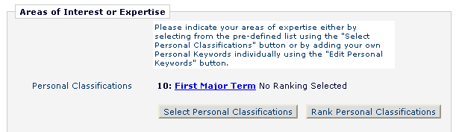

Clicking the ‘Rank Personal Classifications’ button will direct you to a pop-up window where users have the option to rank their experience level for each Classification as ‘Low’, ‘Medium’ or ‘High’.

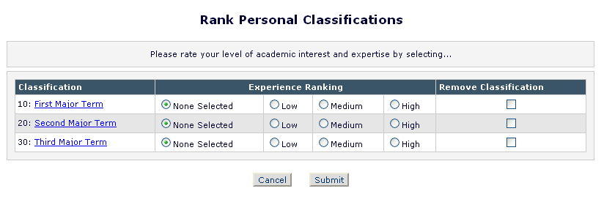

Entering Keywords

If the publication is using Personal Keywords, users may enter free-form Keywords that identify areas of expertise not included in the predefined Personal Classifications list.

Click on ‘Edit Personal Keywords’ to enter free-form areas of expertise. To add a new Keyword, simply type the Keyword(s) into the ‘New Keyword’ field and click on ‘Add’. Click on ‘Close’ when all Personal Keywords have been entered.
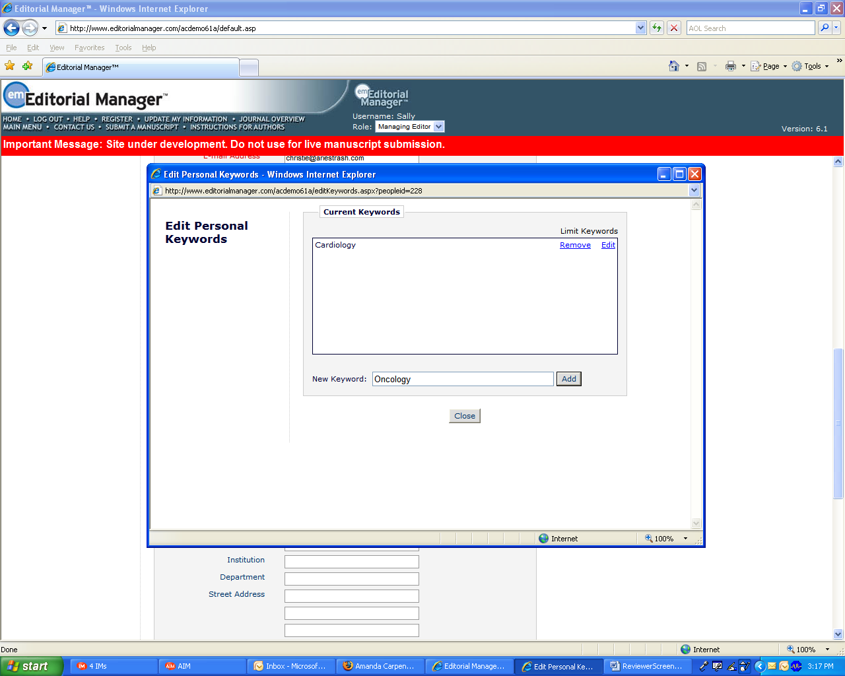

Note: If the Editorial Office has set up Personal Keywords as a requirement, users must enter the minimum number of Keywords indicated.

Choosing a User Name

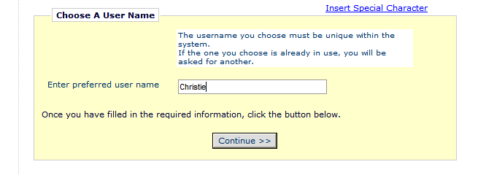

A preferred username must be entered at the bottom of the form. Failure to enter a username or any other required information for registration will result in the display of the following warning:

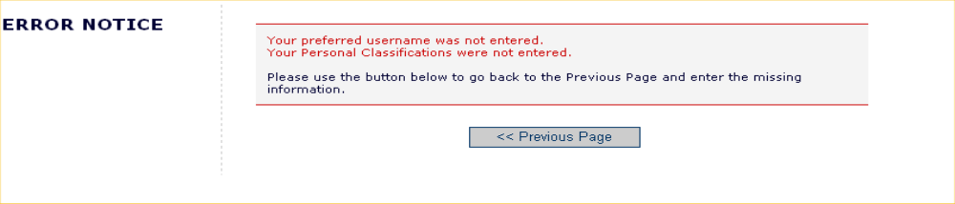

Note: Users must remember this username in order to access the publication’s EM System.

When all information has been provided, click the ‘Continue >>’ button at the bottom to proceed.

A ‘Registration Confirmation’ page will appear, allowing users to ensure that the correct information has been entered.

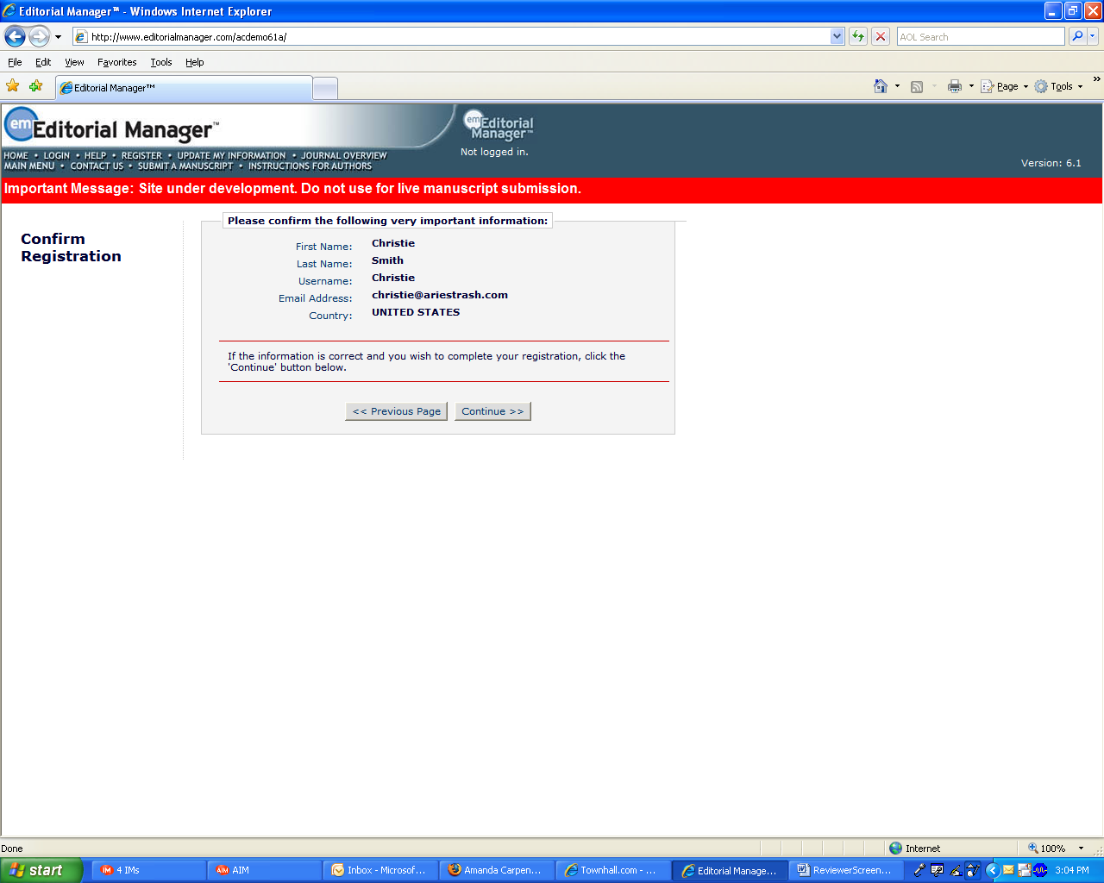

If all fields are correct, click on ‘Continue >>’.The registration process is now complete, and the user may close the browser to check his or her e-mail for the password that has been sent by the system.

Custom Registration Questions
If the publication has opted to require that users respond to registration questions, the following step will appear before the registration process can be completed. A box with an asterisk next to it indicates required information.

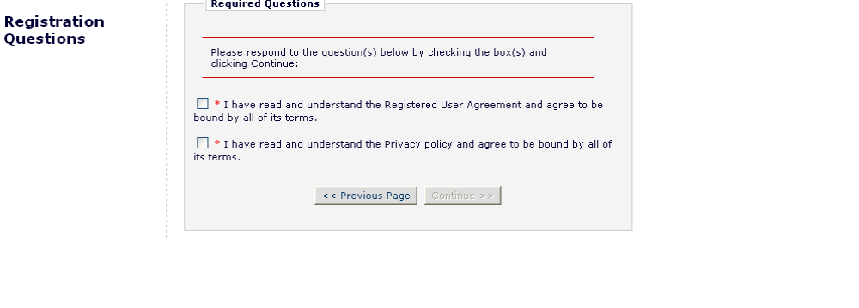

The questions are completely configurable by the Editorial Office. Once the necessary information has been provided, click on the ‘Continue’ button to proceed.

Multiple E-Mail Address Request

Users are strongly urged to enter a second e-mail address. If, for some reason, the system e-mails get caught in a SPAM filter for one e-mail address, users will receive the message at a secondary e-mail address from a different service provider.

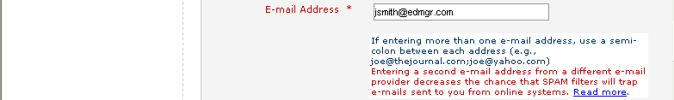

The ‘Read more’ link displays this warning:
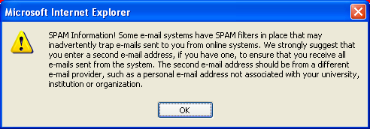

Proxy Registration

When an Editor invites a Reviewer to review a submission, and the Reviewer is not already registered in the publication’s Editorial Manager site, the Editor is given the option to ‘Proxy Register’ the new user. The Editor must supply the minimum information of ‘First Name’, ‘Last Name’, ‘E-Mail Address’ and ‘Country.’ If a user has been proxy registered, he or she may receive an e-mail detailing this username and password. Users may also receive an e-mail invitation to review a paper. The e-mail will usually contain links that point to the publication’s site and to the paper that the Reviewer has been invited to review. Reviewers may choose to ‘Accept’ or ‘Decline’ the invitation.

If the Publication Office has registered on behalf of a Reviewer, the first time the user logs in to the system, he or she will be prompted to enter any additional information the Editor may not have included in the record.

Logging In

Once a user has received a notification e-mail from EM containing the username and password, he or she can login and begin to use the system.

Go to the publication’s EM website. A set of menu options are available from the main navigation menu at the top of the screen. Click on ‘LOGIN’ as shown below:



The Editorial Manager Login screen (see below) will be displayed. The Reviewer enters a username and password in the appropriate fields. If asked to review a paper, the user should click on the tab labeled ‘Reviewer Login’. This will display the ‘Reviewer Main Menu’, which will contain a list of functions that the Reviewer role has been given permission to perform on the system.

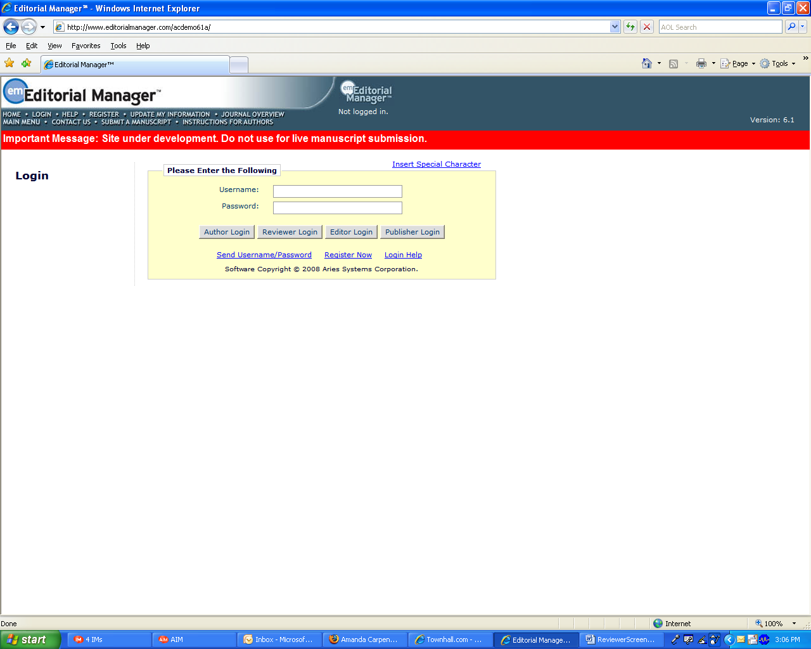

Within EM there are ‘ROLE’ families to which users belong. Each role is given a set of permissions and a user can have multiple roles on the publication. When a user is first registered he or she will, by default, belong to the ‘AUTHOR’ family. If asked to review a paper, the Reviewer then clicks on the button labeled ‘Reviewer Login’. However, if at any time in the future, a Reviewer would like to submit a paper to the publication, he or she would need to click on the button labeled ‘Author Login’.

Once successfully logged in, the Reviewer will be brought to the Main Menu, which will display any New Reviewer Invitations, Pending or Completed assignments – these links are also referred to as ‘Folders’. The number of assignments within each folder will be displayed by the side of the entry.



Time Zone Display

Depending on the configuration of your publication, you may see a ‘Time Zone Footer’ frame when logged into Editorial Manager. This displays the current site time as well as your local time. Clicking on the link ‘Site time’ brings up a pop-up window providing additional time zone information.
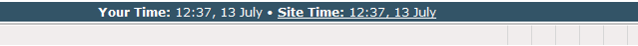

Multi-Language Toggle

If your publication is configured with secondary languages, you will see a ‘language drop down’ located on the navigation bar. Here you may choose to display the site in a language other than the Publication’s default language by selecting from the list of available languages. Your preferred language is recorded as the one most recently displayed. If you switch to an alternate language, the system records your preference, and will display the site in that language at each subsequent login.

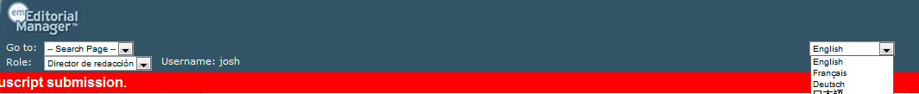

Changing a Password

Passwords may be changed at any time, but the user must first be logged in to the system. From the main navigation menu at the top of the screen (see below), the user will click ‘UPDATE MY INFORMATION’:



The ‘Update My Information’ page dialog boxes will be displayed (see below):

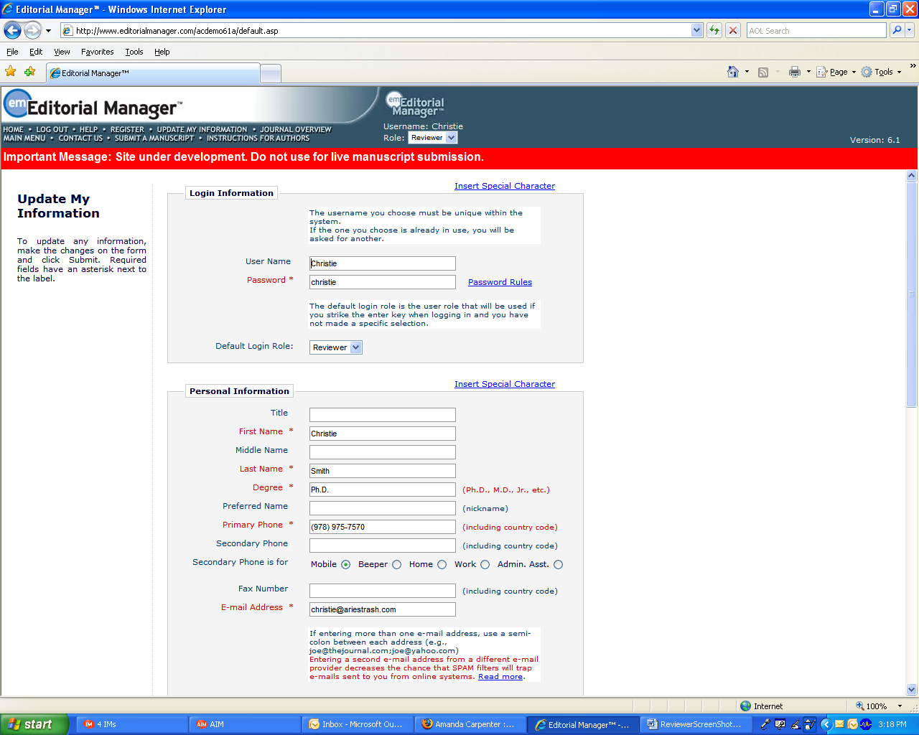

The user will then be redirected to the ‘Reviewer Registration’ screen where he or she may look at all of the information currently available to the publication, and may update fields as appropriate.

Once changes have been made, the user clicks on the button labeled ‘Submit’. EM will check to see if all of the required fields have been completed – if not, the following warning will be displayed:

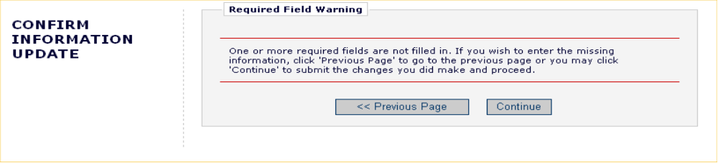

The user may return to the information pages (click on the ‘<< Previous Page’ button), or can simply click on the button labeled ‘Continue >>’.

Entering Unavailable Dates
EM allows users to enter ‘Unavailable Dates’ from the Additional Information section of the ‘Update My Information’ page. These unavailable dates can then be taken into account when Editors invite Authors to submit manuscripts.

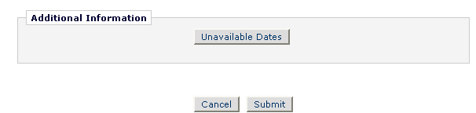

Reviewers enter dates for which they are not available, and provide a short reason for their unavailability. Reviewers can also enter up to three potential substitutes.

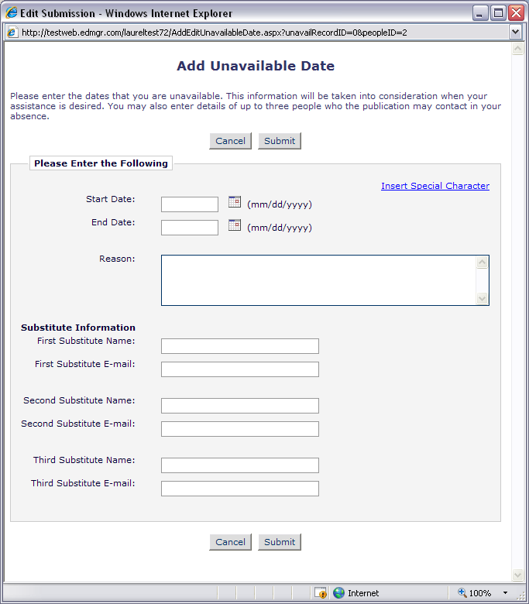

Receiving Reviewer Invitations

Notification of Reviewer Invitations will arrive by e-mail unless you have selected a different Preferred Method of Contact. When invited to review a manuscript, the Reviewer will need to indicate whether the invitation will be accepted or declined. To view outstanding Reviewer Invitations, log into your publication’s website and from the Reviewer Main Menu, click ‘New Reviewer Invitations’. This will provide you with a list of Reviewer invitations that have yet to be accepted or declined.



Users may receive the text of the abstract in an initial e-mail invitation to review. Depending upon how the Editorial Office has configured the invitation process, he or she may also have access to download the manuscript before agreeing to review.

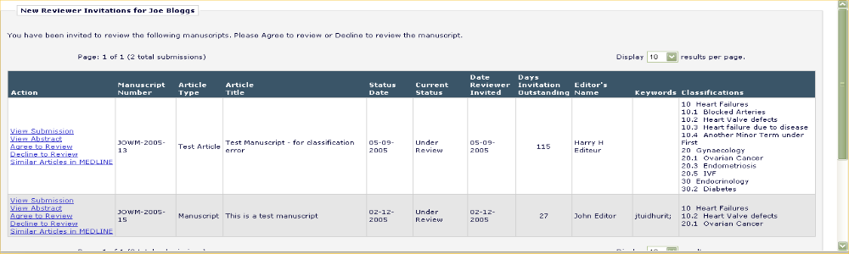

Accepting a Reviewer Invitation

By clicking ‘Agree to Review’, the submission will move from the ‘New Reviewer Invitations’ folder and to the ‘Pending Assignments’ folder, where the Reviewer can begin the review process. Reviewers will also be given confirmation that an invitation has been accepted, as follows:

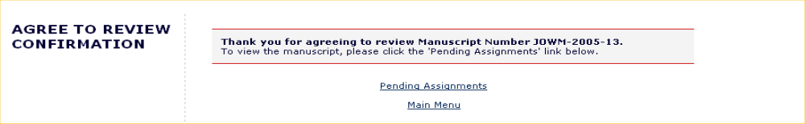

Note: Some due date notification letters may include an iCalendar file allowing you to easily mark the date on your electronic calendar

Declining a Reviewer Invitation

Clicking ‘Decline to Review’ will alert the Editorial Office that the Reviewer will not be reviewing the paper. The system will ask for the reason why he or she is unable to review and will also ask the Reviewer to suggest other potential Reviewers. You must click ‘Submit’ to complete the process of declining an invitation to review.
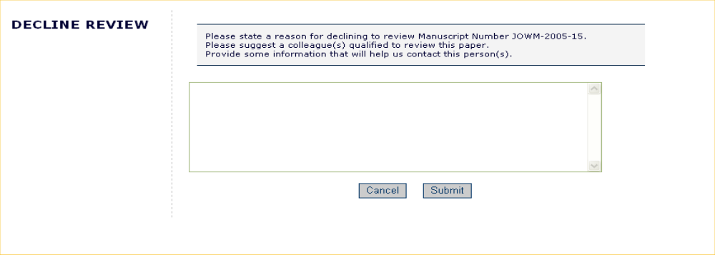

Upon clicking ‘Submit’, the Reviewer will be given confirmation that the invitation has been declined.

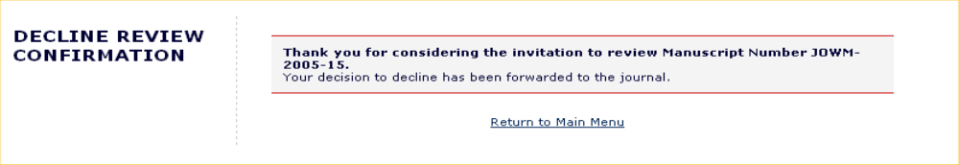

Receiving Reviewer Assignments

Notification of Reviewer Assignments will arrive by e-mail unless you have selected a different Preferred Method of Contact. Reviewers that are assigned to a submission will find the submission in their ‘Pending Assignments’ folder instead of the ‘New Reviewer Invitations’ folder. Publications may use a Deep Link Merge field in the Reviewer Assignment letter which will bring the Reviewer directly to the ‘Pending Assignments’ folder.

Deep Links

Publications may choose to offer direct links to system features from the e-mail communications sent to invited and accepted Reviewers. These ‘Deep Links’ are available for the following Reviewer actions:

- Accept a review invitation - The Reviewer will be able to click on the link to trigger the ‘Agree to Review’ function. If a Reviewer ‘Agrees’ to do the review assignment in this manner, he or she will be fully logged in and will be able to access the submission from the Main Menu.

- Decline a review invitation - The Reviewer will be able to click on the link to trigger the ‘Decline to Review’ function. If a Reviewer ‘Declines’ the review assignment in this manner, he or she will still be brought to the ‘Decline to Review’ page, where he or she will be asked to state a reason for declining the assignment and suggest other qualified Reviewers.

- View Reviewer version of the PDF - This link is available if the Editorial Office configures the invitation e-mail to include it in the notification to the invited Reviewer. The Reviewer will be able to click on the hyperlink to download the Reviewer version of the PDF. The publication may customize the appearance of the PDF cover page to suit the needs of Reviewers. Typically the cover page contains basic information about the submission and can include the Author’s responses to submission questions.

- View Pending Assignment folder - The Reviewer will be able to click on the link for direct access to their ‘Pending Assignments folder. Clicking the link will automatically log the Reviewer into the publication and bring them to the aforementioned folder.

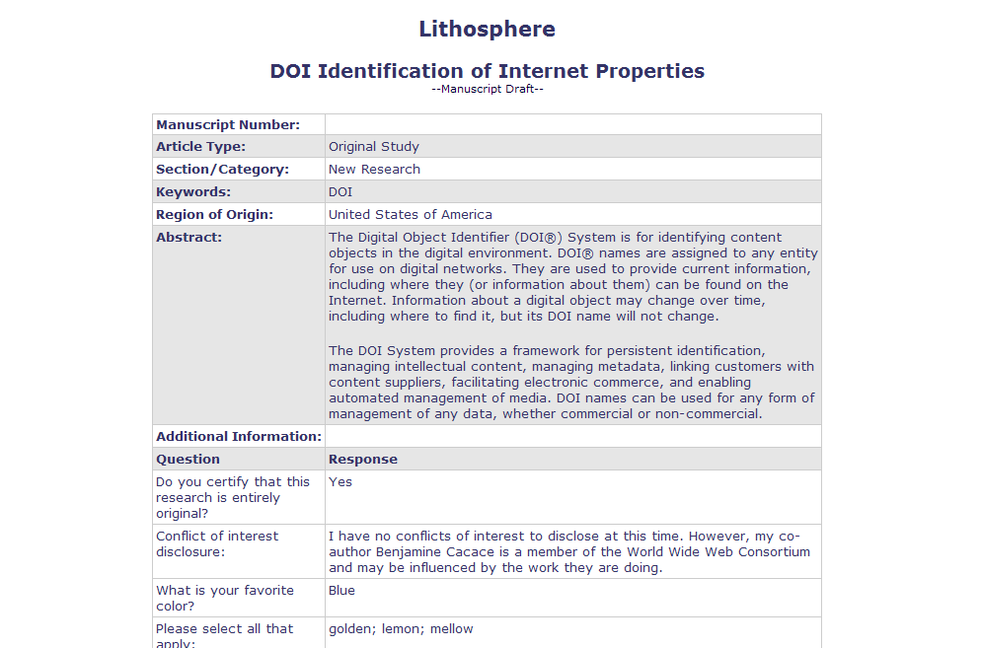

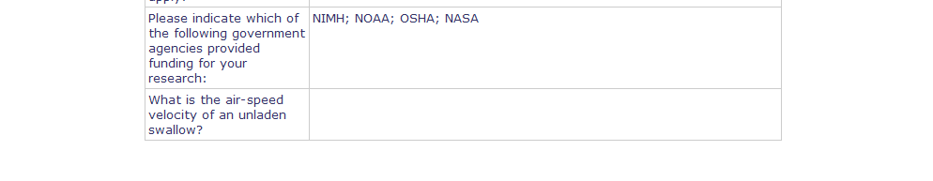

- Update Unavailable Dates – This link is available if the Editorial Office includes it in the e-mail correspondence to Reviewers. Clicking the link automatically logs the Reviewer into the system and brings him or her directly to the ‘Edit Unavailable Dates’ page.

Note: In order for the links in the e-mail to work, a user must NOT be logged into EM. Clicking on the link will open the user’s default browser and will take him or her to the appropriate screen in EM.

Similarity Check Results

If a publication is performing a CrossCheck Similarity Check on submissions Reviewers may be given access to a version of the Similarity Report. If the Reviewer has the ability to view this report a CrossCheck/iThenticate Results Action Link will be available for the submission in the Pending Reviewer Assignments folder. The Score of the report displays next to the link.

Partial page display:
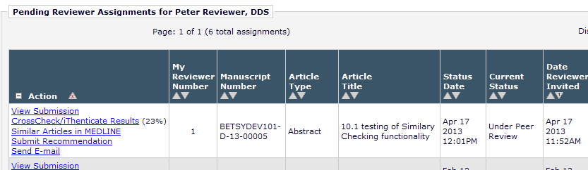

Clicking the link will open the Similarity Report for this submission in a new window. The Reviewer will be able to read the information, but is not logged into the publication’s iThenticate account; they are only viewing the report results.

Sample Page:
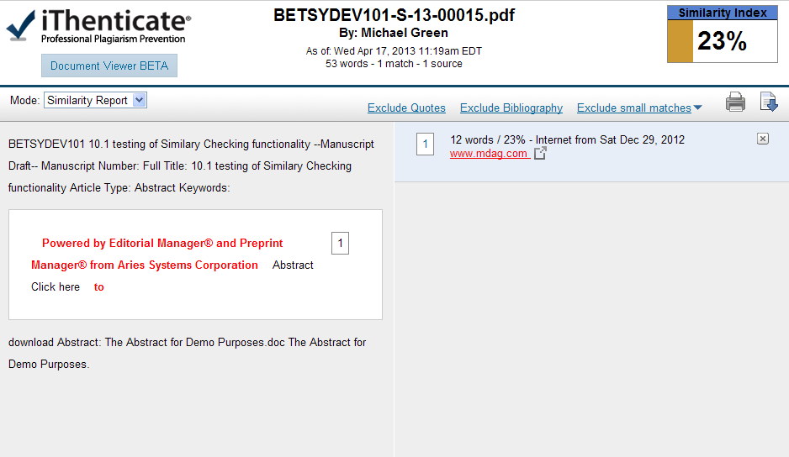

Submitting a Review

Once a Reviewer has agreed to an assignment, they will be able to submit their recommendation. Accepted assignments are keep in the ‘Pending Reviewer Assignments’ folder which is available from the ‘Reviewer Main Menu’.

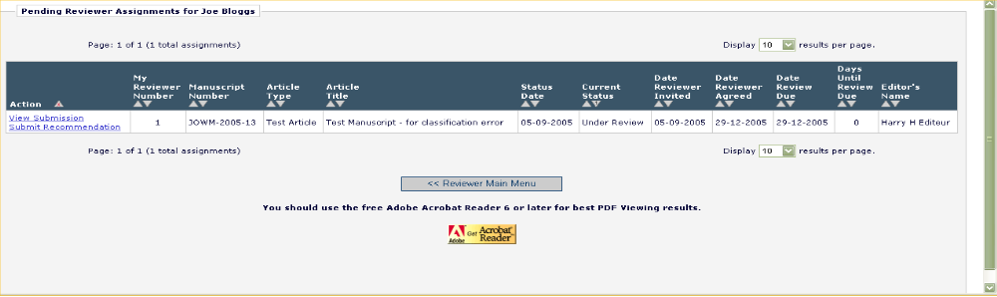

Within this folder a Reviewer may download the PDF of the manuscript to view it on his or her computer by clicking ‘View Submission’ from the available Action Links. This file can also be printed out as a hard copy of the submission should users so desire.

Once a Reviewer is ready to submit a review, the Reviewer can begin the process by clicking ‘Submit Recommendation’. This will bring him or her to the ‘Reviewer Recommendation and Comments’ page.

Note: Reviewers may be automatically un-assigned after they have agreed to review, but before they have submitted their review based on article type configuration by the publication. It is still possible to manually un-assign Reviewers once they have accepted an invitation.

Reviewer Recommendation Page

On the ‘Reviewer Recommendation and Comments’ page, Reviewers will be asked to provide their recommendation, answer any pre-configured questions from the publication and provide their own written comments.

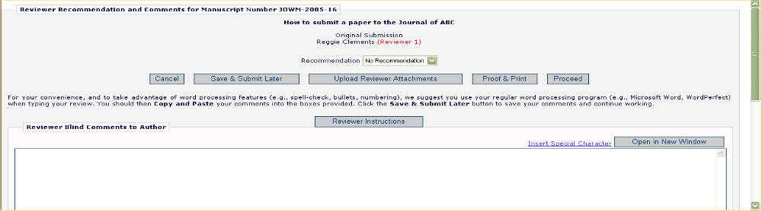

Selecting a Recommendation

Reviewers can choose a recommendation term via the drop-down menu available for ‘Recommendation’. The terms available to a Reviewer are preconfigured by the Editorial Office and can vary from one publication to another. Still, the terms will typically fall into the broad categories of Accept, Revise, or Reject.

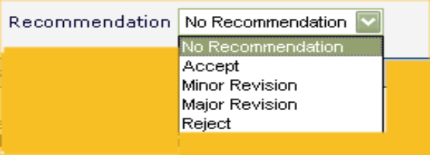

If the submission being reviewed is a new, rather than revised submission, the publication may also request that an overall rating to the manuscript (1–100) be assigned.

If questions arise during the review process, the publication will have likely provided instructions for Reviewers. Users can access these instructions by clicking the button labeled ‘Reviewer Instructions’ near the top of the page.

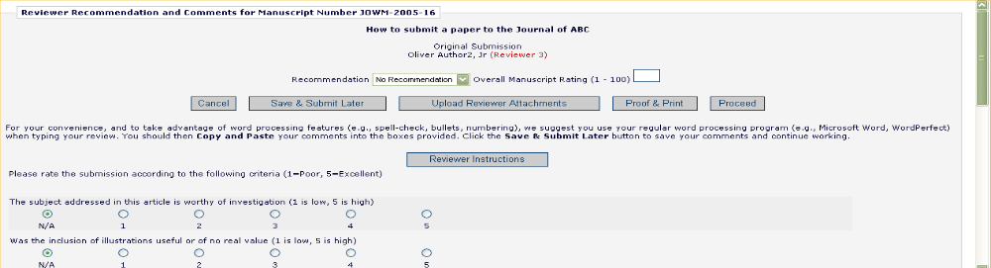

The Review Form

The contents and format of the Review Form will vary from one publication to another as Review forms are configured by the Editorial Office, but Reviewers will typically be asked to answer Manuscript Rating Questions or Review Questions on the ‘Reviewer Recommendation and Comments’ page.

Manuscript Rating Questions will always limit the Reviewer to responding on a 1-3, 1-5 or 1-10 scale, whereas Review Questions will offer varied methods of providing responses.

Following these questions text boxes will be present to allow Reviewers to provide their comments to the Editor as well as to the Author.

If a question is displayed but not required on a Review Form, Reviewers may leave the response blank. If, however, Reviewers choose to answer the question, the minimum character count must be met, even if the question is not required.

Publications may also ask that Reviewers enter comments to the Author and Editor using the provided ‘Reviewer Blind Comments to Author’ and ‘Reviewer Confidential Comments to Editor’ fields. For convenience, Reviewers may use a regular word processing program (i.e., Microsoft Word, OpenOffice, WordPerfect) when typing a review. Reviewers should then ‘copy’ and ‘paste’ the comments into the boxes provided. Click the ‘Save & Submit Later’ button to save comments and continue working. Clicking the ‘Open in New Window’ button at the top right of the data entry fields will open the field in a new browser window, providing the user with a larger view of the review field. Use of these fields is at the publication’s discretion.

Clicking ‘Proof & Print’ will open a window containing all of the review information, as a way to make a printout of the review.

The Reviewer must click ‘Submit Now’ to proceed. This will bring up a screen that allows the Reviewer to proofread before sending it to the Publication Office. If further edits are needed, click ‘Edit Review’. If satisfied with the review, click ‘Submit Review to Journal Office’.

On the ‘Reviewer Recommendation and Comments’ page, the Reviewer Instructions and Review Form text will be displayed in the comments box.

Example: Reviewer Recommendation and Comments’ page 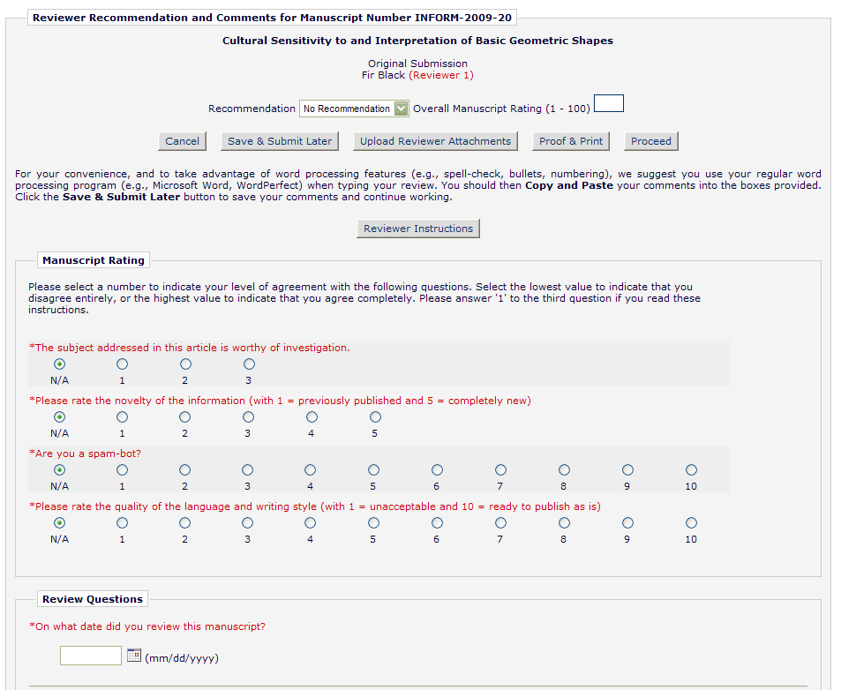
Date response type

Notes response type

Decimal response type

List: radio buttons response type

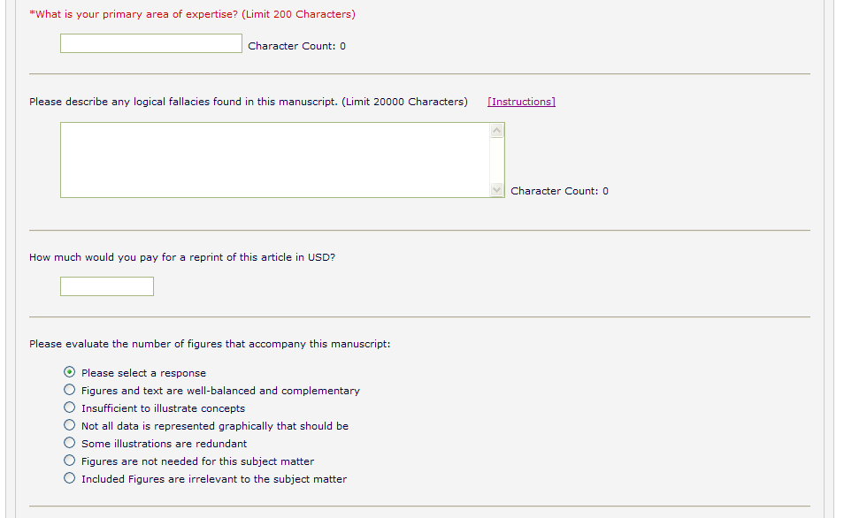
Text response type

[continued on next page]
[continued from previous page]
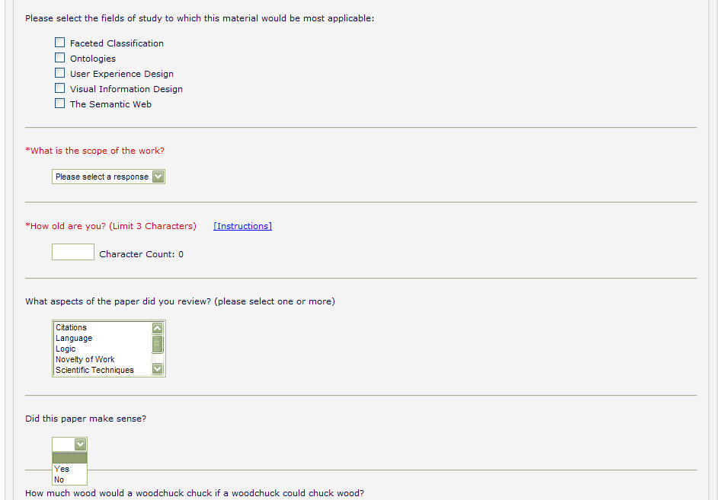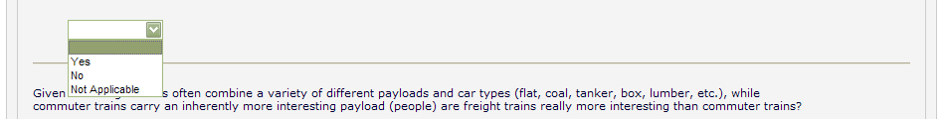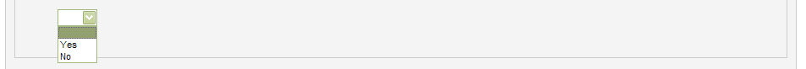
List: checkboxes response type

List: dropdown response type
Integer response type

List: scrolling selector response type

Yes/No response type
Yes/No/NA response type
Yes/No/Text response type

Attachments

If the Editorial Office has enabled this feature, Reviewers may upload files into the system as part of the ‘Submit Recommendation’ process. Reviewers may want to upload annotated manuscripts, non-manuscript files such as images or related materials.

Reviewers may upload any files that are appropriate to the review. Reviewers can download or remove attachments prior to submitting a review. Files are uploaded by clicking the button labeled ‘Upload Reviewer Attachments’.

Reviewers may provide a description before attaching any files and can attach single or multiple files to the review. Each file is listed separately, and the ability to Download and Remove is available for each uploaded file.

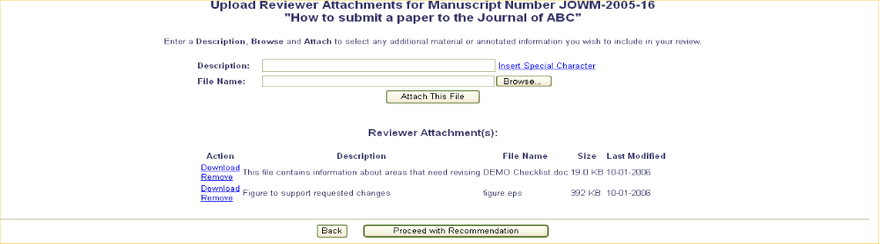

Please take note of the following:

- Care should be taken as some attachments may contain information revealing the originator's identity, including information that appears in a file's 'Properties' (on Windows) and 'Get Info' (on Macintosh).
- Authors and Reviewers are not sent these Attachments via e-mail. The Attachments made via the Reviewers recommendation process can only be accessed through the EM site.
- Reviewer Attachments, including edited versions of the Attachment, can only be accessed by the Reviewer who attached the file. This means that Reviewers cannot access other Reviewer’s attachments.
- This function does not affect the PDF, nor does it add or edit files of the actual submission.

When review files have been uploaded, the Reviewer must click on the button labeled ‘Proceed with Recommendation’. If changes need to be made, click on the button labeled ‘Back’. If no files have been attached, the following warning will be displayed:

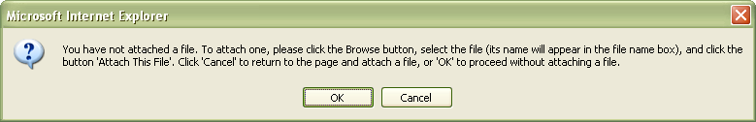

Click ‘OK’ to proceed without adding a file or press ‘Cancel’ to go back and attach one.

Submitting the Review

Once the Reviewer has filled out the Review Form with all required information and provided any relevant Attachments, the Reviewer should click ‘Proceed’ from the ‘Reviewer Comments and Recommendation’ page.

A summary screen will be displayed. This information should be checked for accuracy and edited if necessary. If all of the information is correct, click on the button labeled ‘Submit Review to Journal Office’.

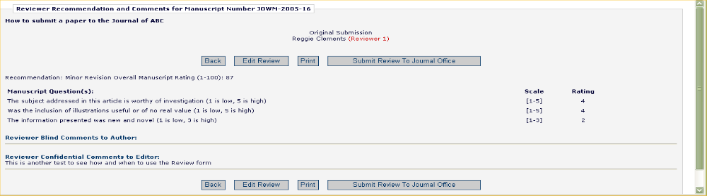

The Reviewer is given a final opportunity to check the recommendation – click on OK to proceed or Cancel to make further changes.

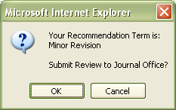

Once the review has been successfully submitted, the Reviewer will receive a screen thanking him or her for the review and will see a button to return to the main menu.

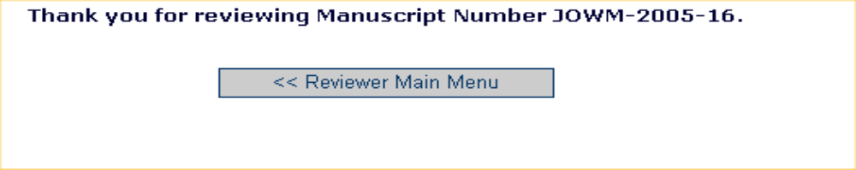

Re-Opened Reviews

Editors at a publication may choose to re-open a Reviewer’s submitted review if information is missing or there is a need for further clarification. When a review is re-opened a notification will be sent to and the assignment will be moved back to their ‘Pending Reviewer Assignments’ folder. From there the reviewer will be able to modify the previously submitted review and re-submit it to the Editorial Office.

Communicating with the Editorial Office

During the review process a Reviewer may wish to contact the Editorial Office. This may be done through Editorial Manager using the ‘Send E-Mail’ Action Link available in the ‘New Reviewer Invitations’, ‘Pending Assignments’ and ‘Completed Assignments’ folders. Using this feature will give the Reviewer access to several template letters that can be sent to members of the Office Staff.

If the publication has provided access, the Author will see a ‘Send E-mail’ link within the list of available actions. This will allow the Author to send an e-mail to the publication at any time. The publication will have set up either one or multiple Ad Hoc e-mails that can be modified for use by an Author. In some cases, using an Ad Hoc letter will allow users to attach files to the letter by choosing from personal files.

When an Ad Hoc letter is configured to allow attachments, then the sender of the letter will see a new ‘Add/Change Attachments’ button on the ‘Customize Letter’ page.

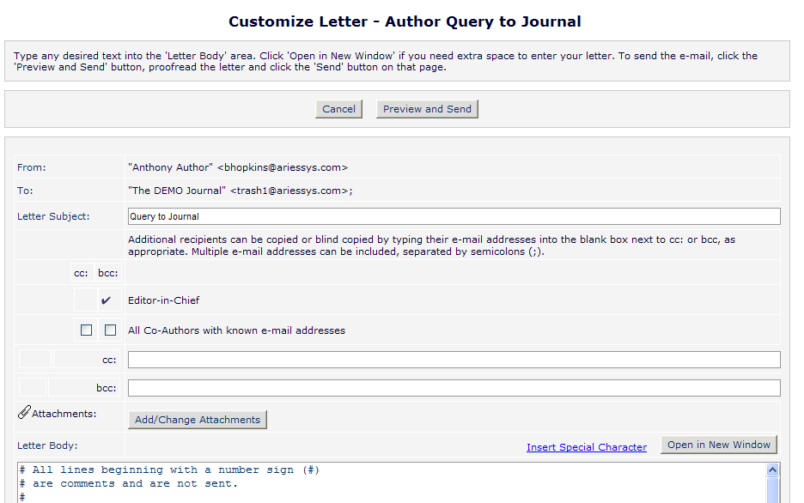

Clicking the ‘Add/Change Attachments’ button will open a window where files can be uploaded as an attachment from a user’s local computer by clicking the ‘Browse’ button and choosing the file to be added.

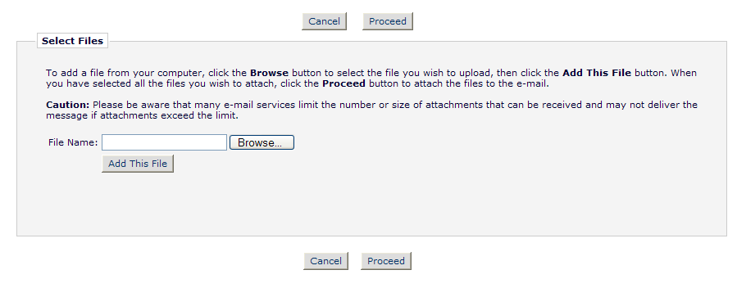

When the upload is complete, the attached file will display in a grid on the page. When the user is done adding and selecting files, clicking the ‘Proceed’ button returns the user to the ‘Customize Letter’ page.

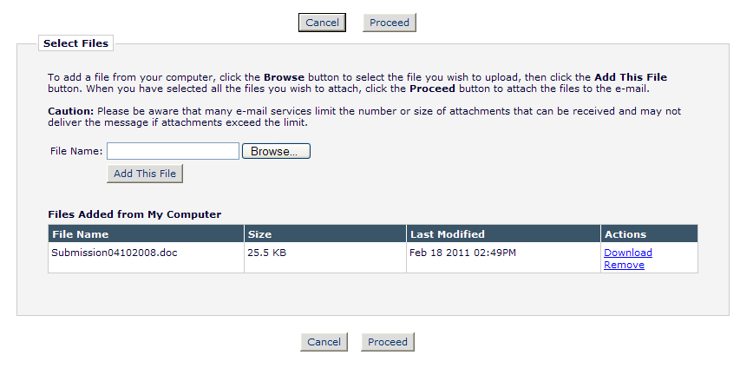

The attached files now display above the ‘Add/Change Attachments’ button. If the user clicks the ‘Add/Change Attachments’ button again, any files already attached are listed in the file table in the order they were attached. If the user deselects or removes any previously attached files and clicks ‘Proceed’ on the ‘E-mail Attachment Upload’ page, they are removed from the letter.

Receiving Attachments

Upon accepting an invitation to review a manuscript, Reviewers may be given access to Attachments provided by other Reviewers or an Editor. Access to these Attachments may be granted through a link in the invitation e-mail, but they can also be accessed using the ‘View Attachments’ Action Link which will be available when viewing the submission. This link will provide access to any Attachments which the Editor has authorized Reviewers to view.

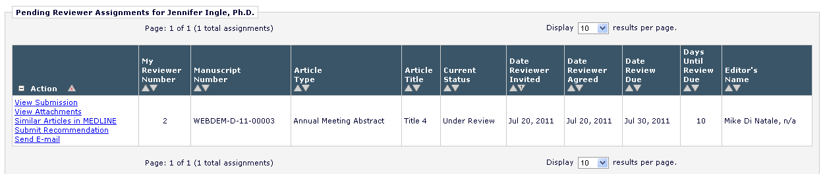

Author Response to Reviewers

Reviewers will be able to view an Author’s response to Reviewers of the previous revision along with the Reviewers’ original comments if the publication has made that information available. To access the Author’s Response to Reviewers, follow the ‘View Reviewer Comments’ Action Link when viewing the submission in Editorial Manager.

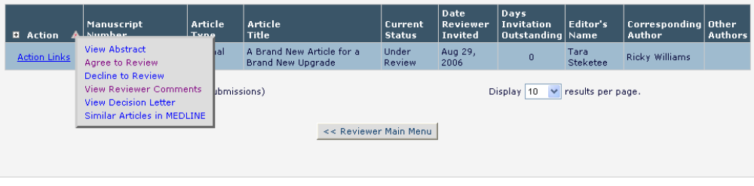

A pop-up box will appear with a link to the ‘Author’s Response to the Reviewers’ comments:

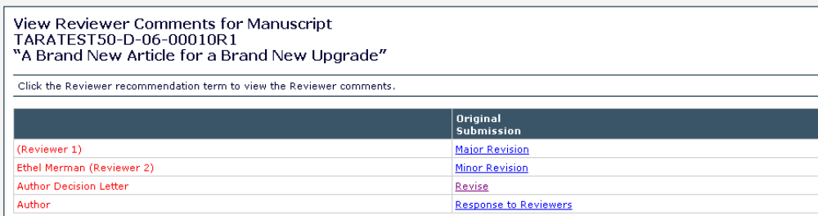

When the Reviewer clicks on this link, the Author’s response to all of the Reviewer comments will be listed:



