Supplementary Materials

Distribution of brominated flame retardants and phthalate esters in house dust in Korea

Deok-Jun Kweon, Moon-Kyung Kim, Kyung-Duk Zoh†

Department of Environmental Health Sciences, School of Public Health,
Seoul National University, Seoul 08826, Republic of Korea

Submitted to Environmental Engineering Research

Corresponding Author

Kyung-Duk Zoh

Tel: 82-2-880-2737
Fax: 82-2-762-2888
Email: zohkd@snu.ac.kr

1. QA/QC for the Measurement of Phthalates and Brominated Flame Retardants Using LC/MS-MS

1.1. Calibration
Internal standard calibration was adopted for quantification. Because the extraction method was reliable by the results of the recovery test, liquid calibration with the internal standard spiked could be used for quantification of target compounds. Original solutions of the standards were diluted to the concentration of sensitivities targets showed. PBDEs mixture standard was made in a range of 50-1,000 μg L⁻¹ for GC/MS, and respective HBCDs and TBBPA was prepared in a range of 1-50 μg L⁻¹ for LC/MS-MS. In case of phthalates esters, the mixture standard was diluted to 20-5,000 μg L⁻¹, gradationally. Mainly detected esters (DEHP, DBP, BBP) were calibrated in a high concentration range of 0.1-5.0 mg L⁻¹, whereas, the others (DIBP, DAP, DHP, DNOP) were in a lower concentration range of 20-500 μg L⁻¹. Multi-level calibration curves (r² > 0.99) in the linear response were created for each component.
Before using the internal standards, we confirmed that they were certainly usable by the test with the only dust samples without spiking them. Those compounds were confirmed using as the internal standards because no peaks at the same retention time with them were detected in mass chromatography. They were prepared in n-hexane at respective concentration. Every glassware such as extraction vials, glass syringes and pipettes of different sizes were rinsed with same washing solvent and then baked at 400ºC in muffle furnaces for dehydration and decontamination for 2 h and then cooled down to room temperature in desiccators before use. Anhydrous sodium sulfate (pesticide residue analysis grade, Kanto, Japan) was also baked at 400°C (Abb et al. 2009)

1.2. Recovery
Surrogate recoveries for PBDEs, HBCDs/TBBPA in low concentration were between 74 and 97%, and averaged 84 ± 4% for PCB-166. Also, the recoveries for PBDEs, HBCDs/TBBPA in high concentration were between 77 and 97%, and averaged 88 ±4% for PCB-65. For phthalates, they were between 76 and 122%, and averaged 98 ±14% for DBP-d₄.

1.3. Limits of Determination
The mixture standards of PBDE congeners and phthalate esters were used for GC/MS and the mixture of each HBCD and TBBPA standards were for LC/MS/MS. The limit of detection (LOD) were calculated from the concentration value corresponding with the peak showing signal to noise (S/N) ratio of 3:1, and the limit of quantitation (LOQ) were from S/N ratio of 10:1. Also, method detection limit (MDL) for BFRs and phthalates were assessed as multiplying t-value by the standard deviation (SD) of multiple low concentration (n = 7), which were taken from the inspection spiking the mixture standard solution to the target compound free material at the level of LOQ level (Batterman et al. 2010). MDLs were measured by spiking the standard mixture of the target compounds into sea sand matrix instead of dust reference material containing free BFRs and phthalates.
The detected MDLs of PBDEs were 2 ng g⁻¹ for mono- to octa-BDE (BDE-1, -7, -28, -47, -99, -100, -153, -183, and -203), 10 ng g⁻¹ for nona-BDE (BDE-206, -207, and -208), and 50 ng g⁻¹ for deca-BDE (BDE-209) via GC/MS, respectively. The detected MDLs of HBCDs were 60, 60, and 23 ng g⁻¹ for α-, β-, and γ-HBCD via LC/MS-MS, respectively. The detected MDL of TBBPA was 28 ng g⁻¹ via LC/MS-MS. In addition, the detected MDLs for phthalates were summarized in Table S1.

Table S1. The Results of MDLs for Phthalates in Dust Samples
Compounds | MDLs (μg g⁻¹) | Compounds | MDLs (μg g⁻¹)
DMP | 0.2 | DIBP | 0.4
DEP | 0.4 | DBP | 0.2
DMEP | 0.8 | DAP | 0.06
DMPP | 0.5 | DHP | 0.01
DEEP | 1.9 | BBP | 0.5
DBEP | 0.7 | DEHP | 2.5
DCHP | 0.5 | DNOP | 0.6
DNP | 0.2

Table S2. Associations of BFR Concentrations of the Settled Dusts with Building Characteristics in 42 Houses
p-value | Concentrations vs. PVC flooring¹⁾ | Concentrations vs. building age²⁾
BDE-7 | - | -
BDE-28 | 0.932 | 0.649
BDE-47 | 0.878 | 0.062
BDE-100 | 0.184 | 0.877
BDE-99 | 0.173 | 0.894
BDE-153 | - | -
BDE-183 | - | -
BDE-203  BDE-207  BDE-208  BDE-206  BDE-209  ΣPBDEs  ΣHBCDs  TBBPA | 0.142  0.483  0.772  0.421  0.311  0.401  0.275  0.478 | 0.007*  0.749  0.899  0.931  0.955  0.296  0.093  0.698
¹⁾ Mann-Whitney U-test regarding differences in BFR concentration between PVC flooring and wood as flooring material
²⁾ Spearman correlation test of between construction age and BFR concentration (correlative in case p-value is below 0.01)

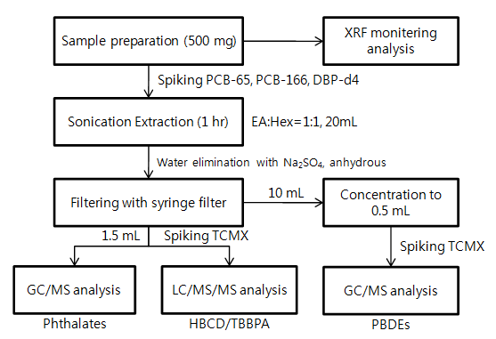
Fig. S1. Flow chart for the analysis of BFRs and phthalates.

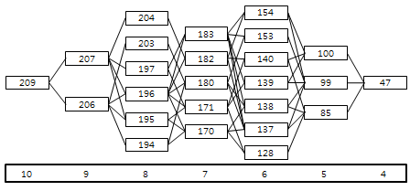
Fig. S2. The chart of debromination of deca-BDE.

References
Abb M, Heinrich T, Sorkau E, Lorenz W. Phthalates in house dust. Environ. Int. 2009:35:965-970.
Batterman S, Godwin C, Chernyak S, Jia C, Charles S. Brominated flame retardants in offices in michigan, USA. Environ. Int. 2010:36:548-556.

